**Step 1:- creating VPC**

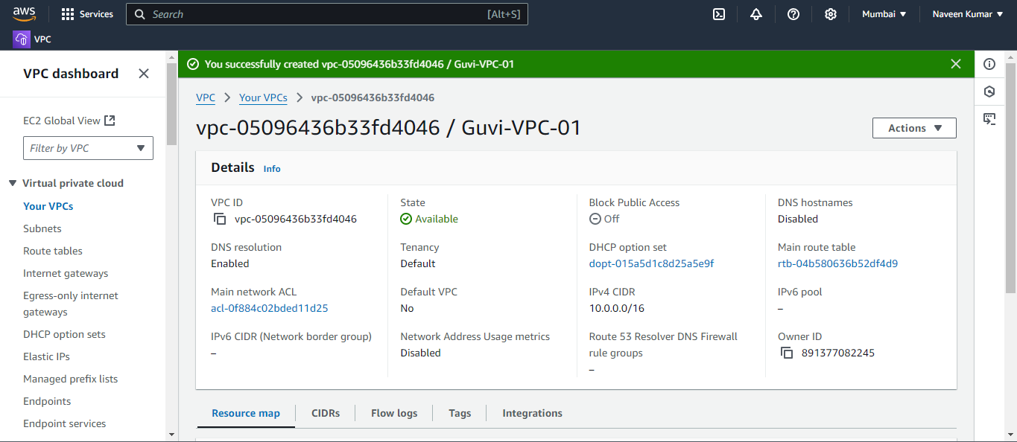

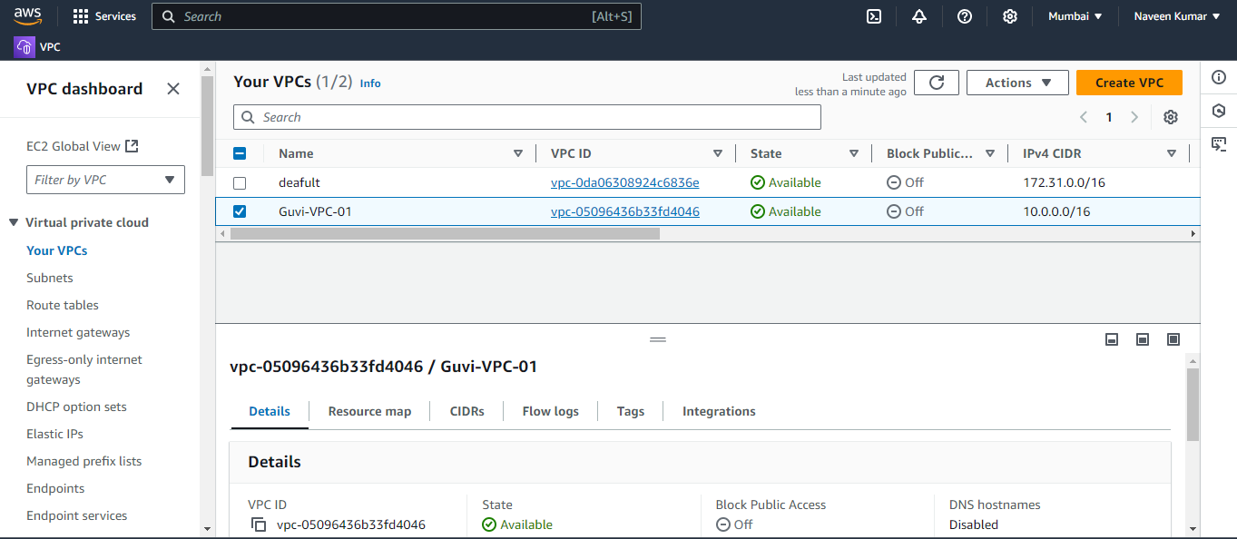

**Step 2:- Creating public subnet and private subnet**

**Public subnet**

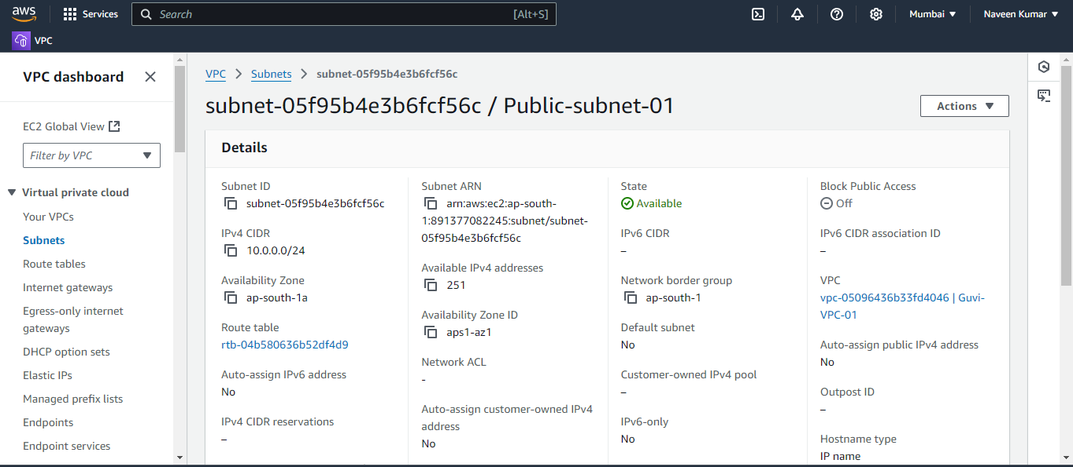

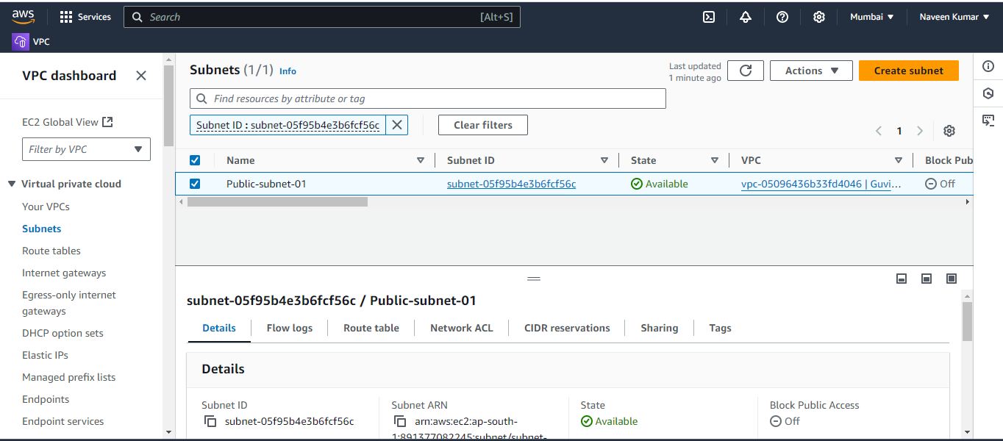

**Private subnet**

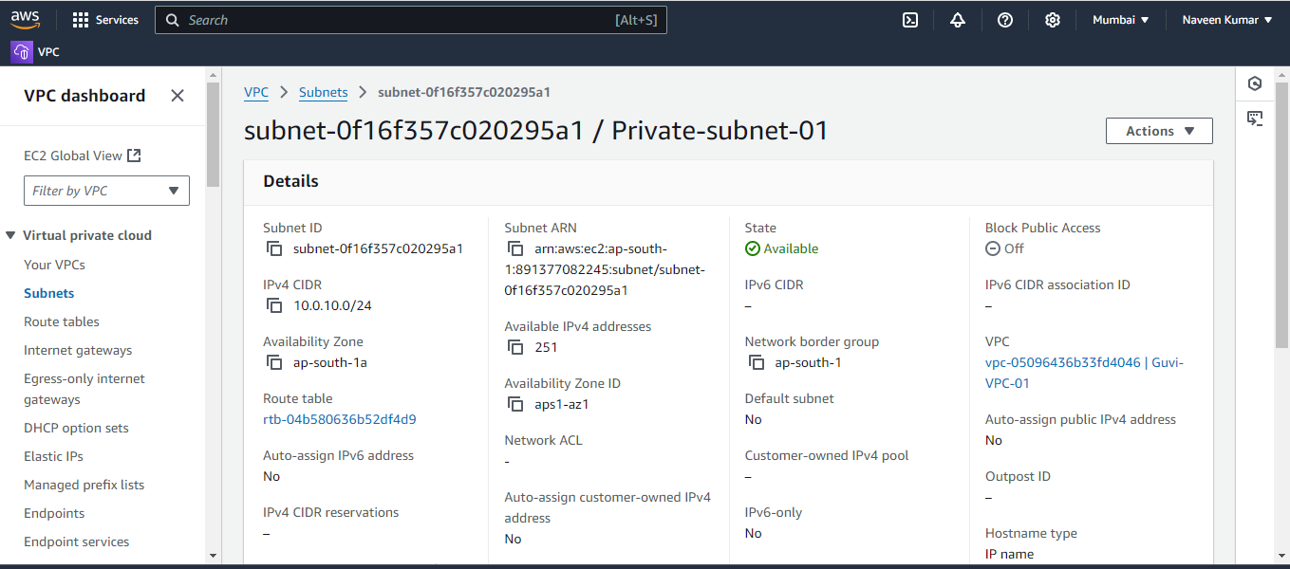

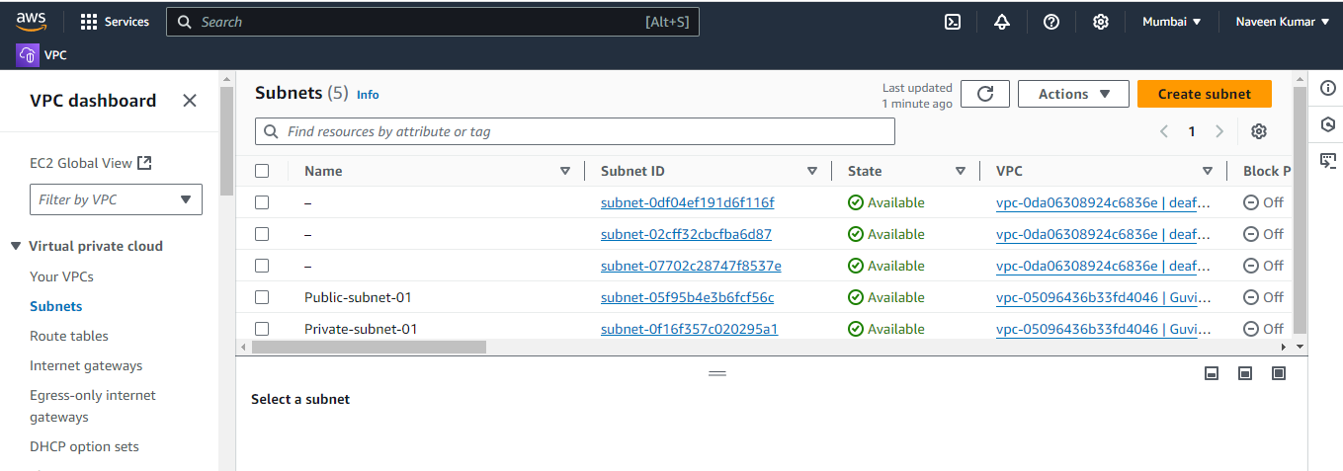

**Step 3:- Creating Route tables for public and private subnets**

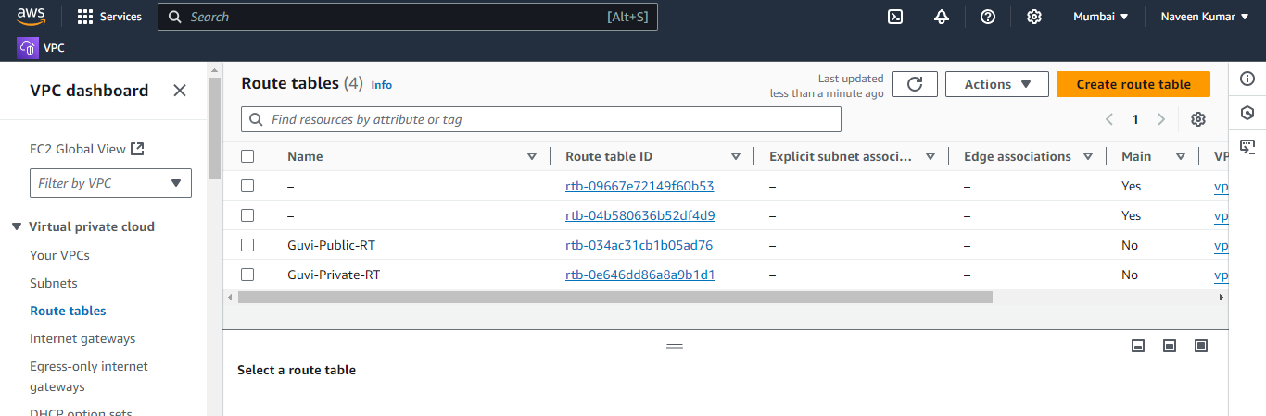

**Step 4:- Associating the RT’s with the respective subnets**

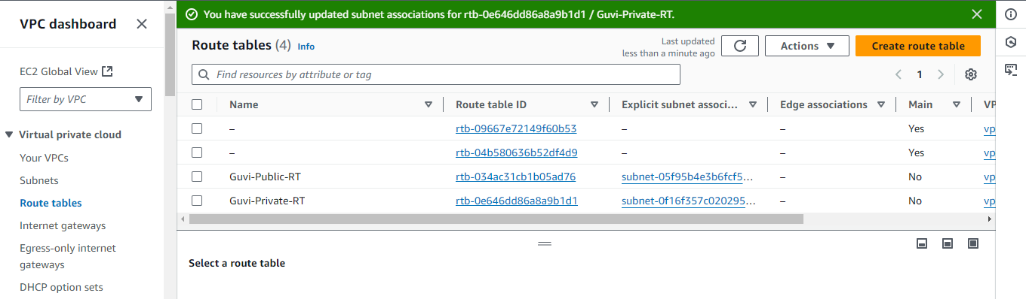



**Step 5:- Creating Internet Gateway (IGW) to VPC**

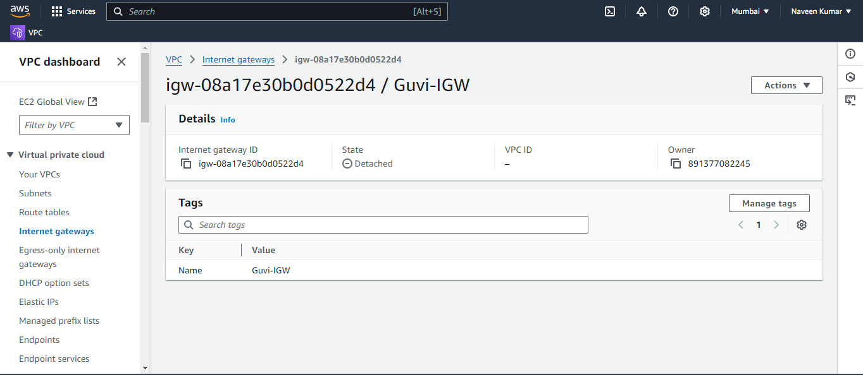

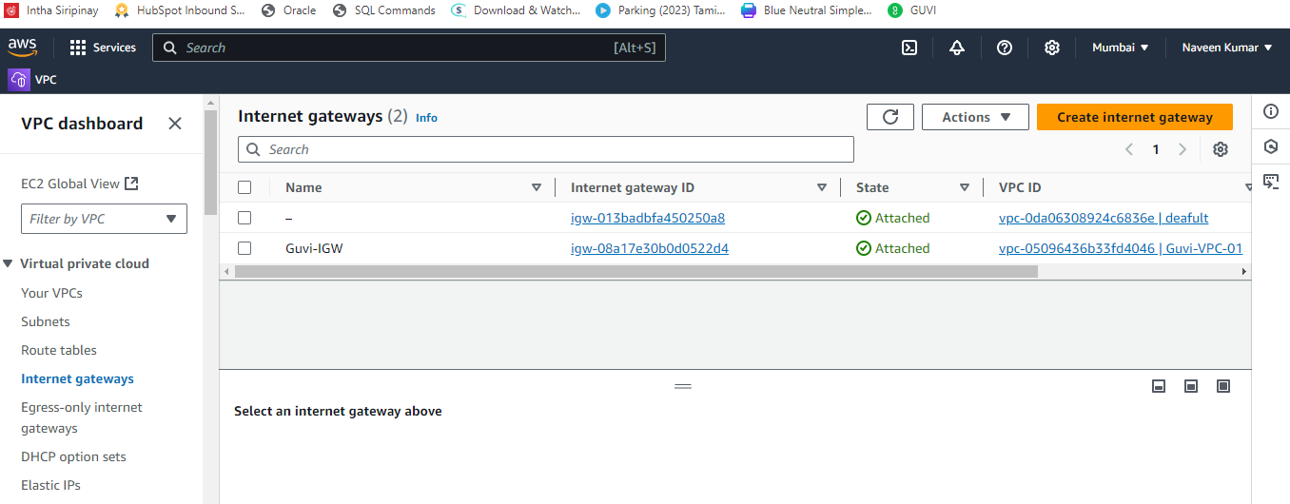

**Step 6:- Specify the IGW to the public subnet**

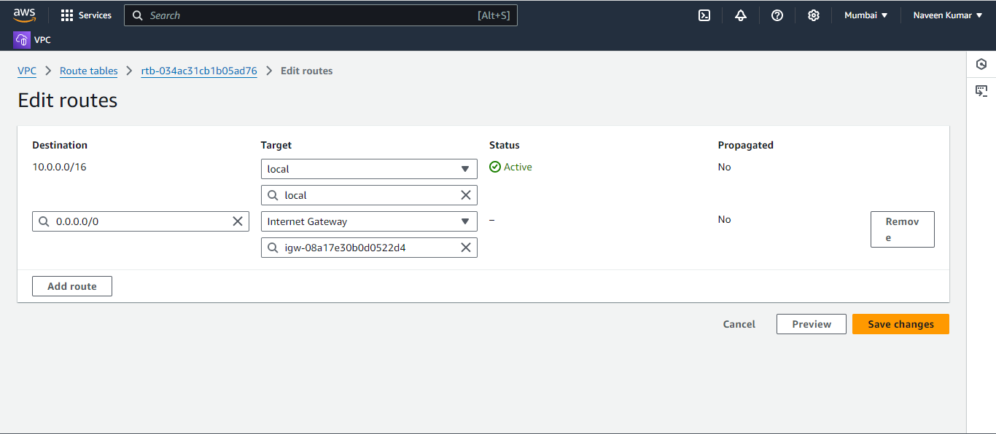

**Step 7:- Creating EC2 instance for public and private subnets**

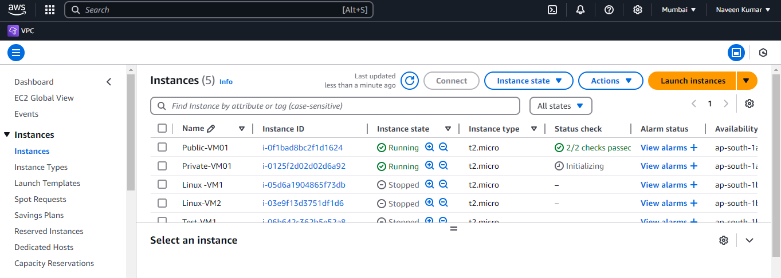

**Creating NAT GAT way and assigning to private subnet**

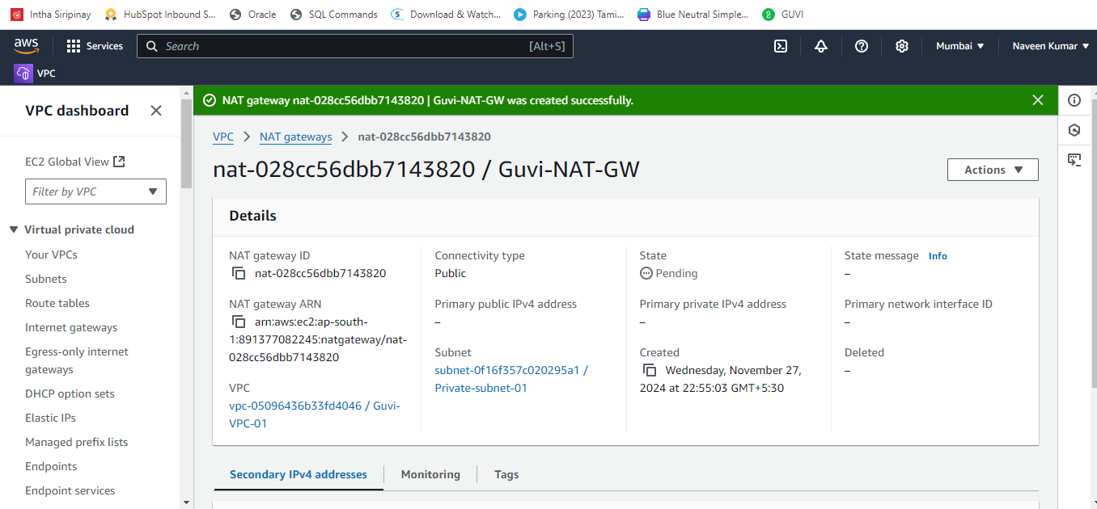

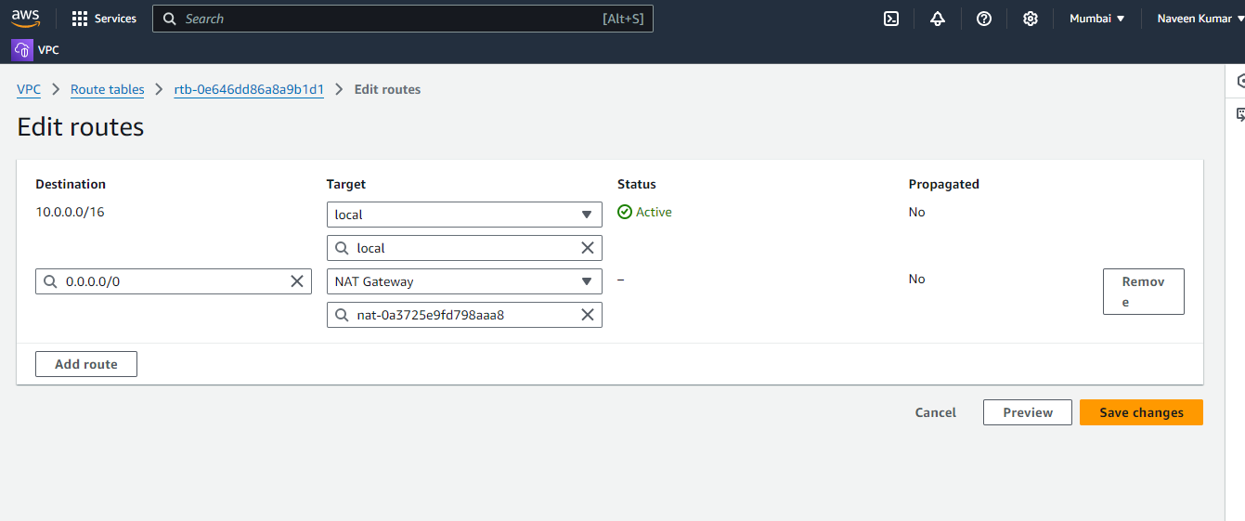

**Connecting the public instance using Putty**

